SING TO THE DAWN
- SYNOPSIS

BAHASA INGGERIS | BAHASA MELAYU
The story, Sing to the Dawn, is about Dawan, a young Thai girl who lives in a village with her family and attends the village school . She is allowed to go to school because of her brother's insistence that his sister be allowed to join him. Dawan and Kwai sit for a special examination which offer the best student a scholarship to study in a city school. Both Dawan and Kwai feel that with more education they will be able to help improve the villagers' way of life.  Dawan wins the scholarship and Kwai, comes in second. This causes a rift between the two siblings who are very close with each other. Dawan is excited about her situation but realises that Kwai is not too happy and even turns hostile towards her. She feels hurt but is determined not to give up the opportunity to further her education. The situation is aggravated by their father who feels that city life and further education are not for a girl.  Dawan tries to get support from her cousin, Noi and the monk but they too do are not on her side. . Only her grandmother and a flower seller, Bao want her to accept the scholarship. Eventually, her father and her brother agree to let Kwai accept the scholarship and study in the city. She goes on her journey with a happy heart knowing that she is capable of taking on the responsibilities it entails. | ‘Sing to the Dawn” mengisahkan tentang Dawan, seorang gadis Thai yang tinggal dan bersekolah di kampong . Dia dibenarkan bersekolah di atas desakan adek lelakinya Kwai. Dawan dan Kwai menduduki peperiksaan yang menawarkan biasiswa untuk melanjutkan pelajaran di bandar bagi pelajar yang mendapat markah tertinggi. Dawan dan Kwai berpendapat dengan pendidikan mereka dapat memperbaiki kehidupan orang-orang kampong.  Dawan telah mendapat tempat pertama dan Berjaya memenangi biasiswa tersebut dan Kwai mendapat tempat kedua. Perhunungan kedua beradek itu menjadi renggang. Dawan sangat teruja tetapi dia sedar Kwai tidak gembira malah berubah dan tidak lagi mahu berbaik dengannya. Dawan merasa sedeh tetapi dia betekad tidak mahu melepaskan peluang untuk meneruskan pelajarannya. Keadaan menjadi lebih buruk apabila bapa mereka juga merasakan budak perempuan tidak memerlukan pendidikan yang tinggi  Dawan cuba mendapatkan sokongan dari sepupu nya, Noi dan seorang sami tetapi mereka enggan membantu. Hanya nenek nya dan seorang penjual bunga bernama Bao yang mahu Dawan memerima biasiswa untuk belajar. Namun begitu, akhirnya, Kwai dan bapa Dawan merestui pemergian Dawan ke bandar untuk melanjutkan pelajaran. Dawan pula merasa gembira dapat melanjutkan pelajaran dan sedar tanggungjawab yang dipikulnya untuk memperbaiki kehidypan masyarat di kampungnya.

B. SETTING

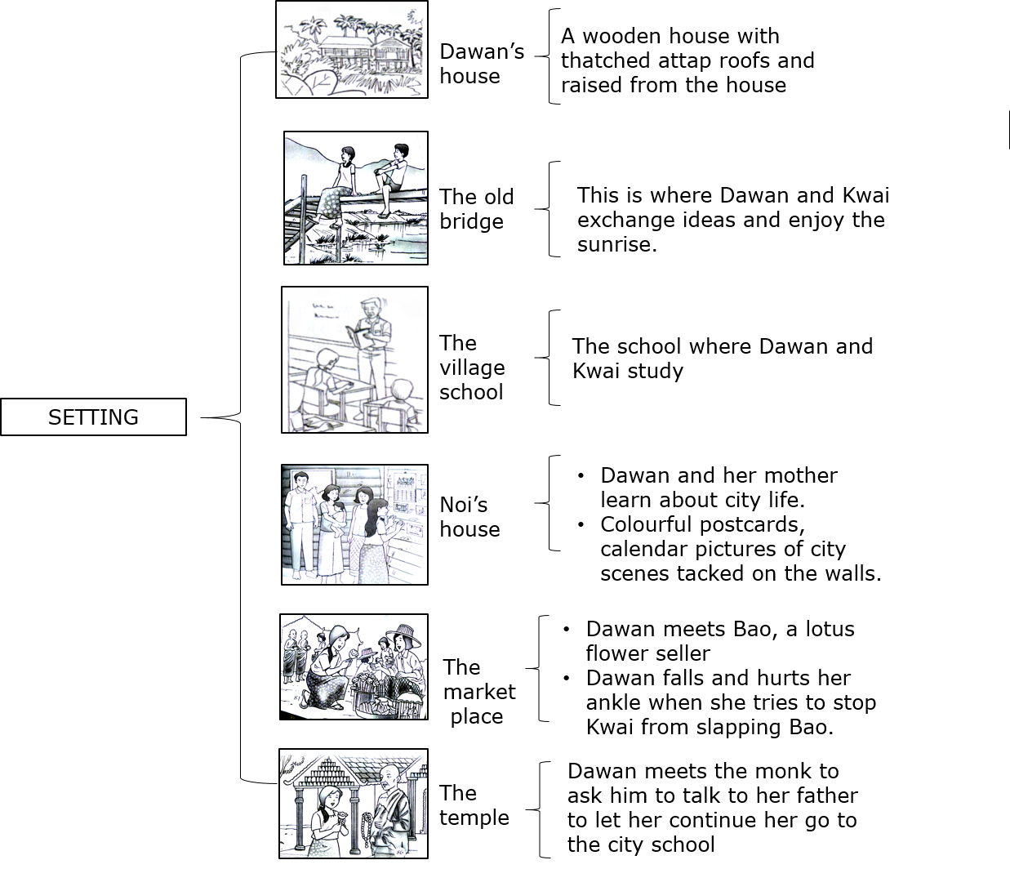

C. PLOT

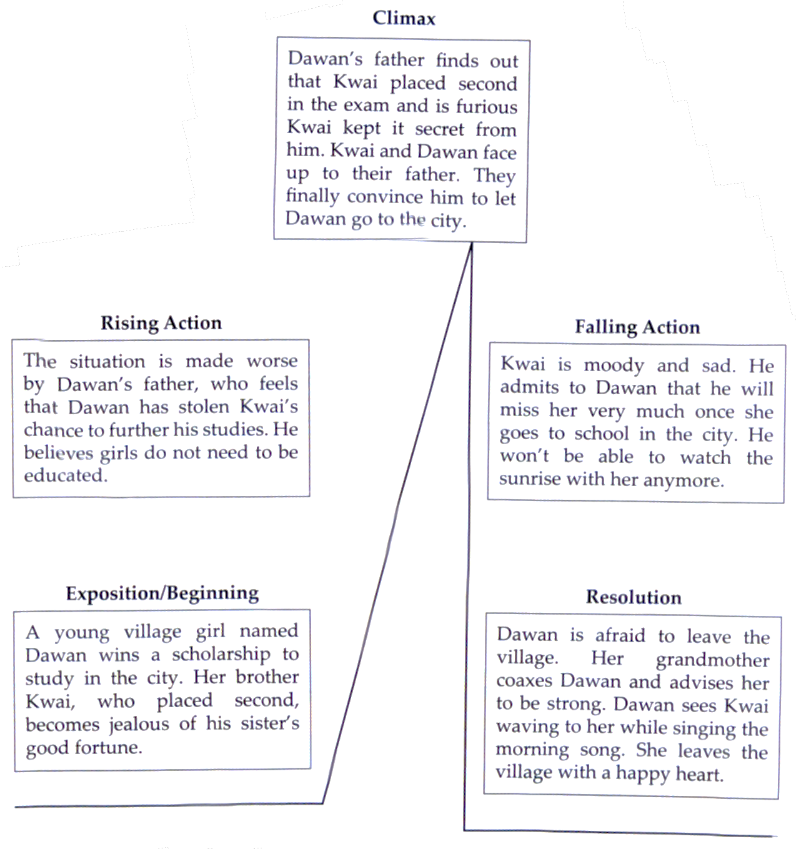

D. THEMES

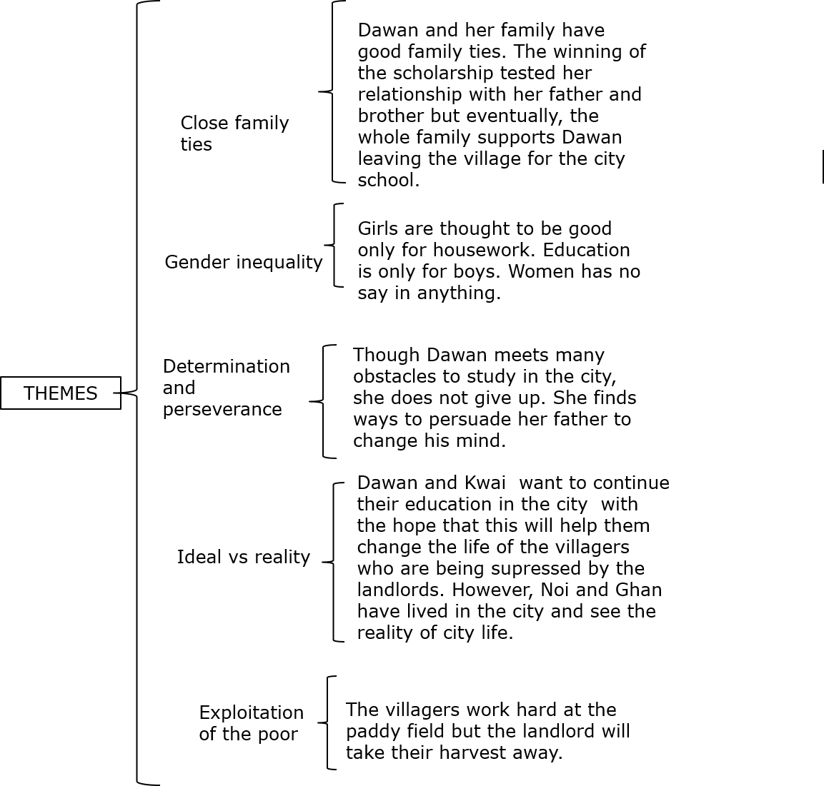

E. MORAL VALUES
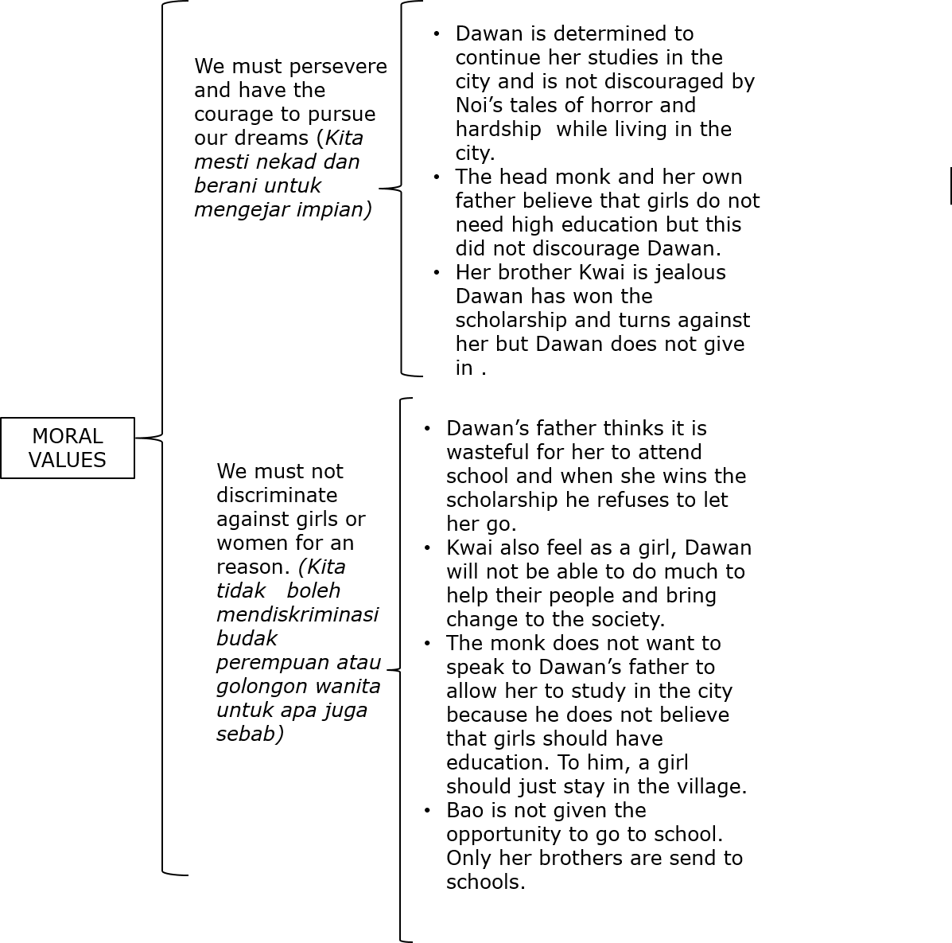

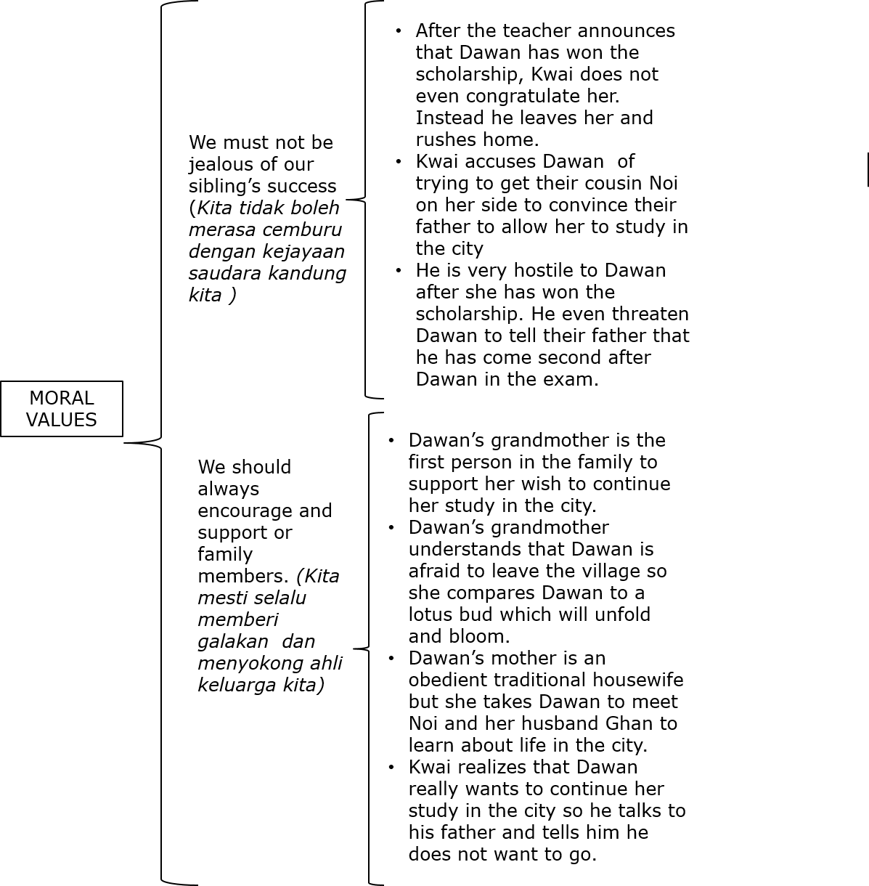
F. CHARACTERS
